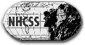
New Hampshire Council for the Social Studies
Advancing Social Studies Education in New Hampshire

and
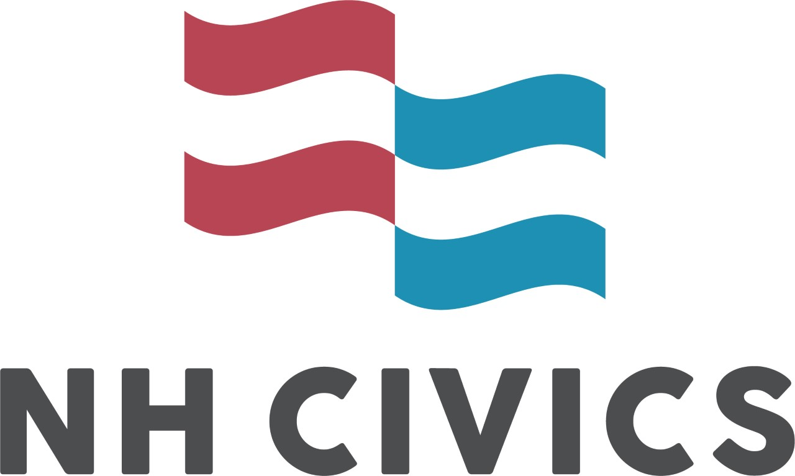
New Hampshire Civics
Developing, nurturing, and maintaining an informed, engaged, and civil New Hampshire citizenry through a greater understanding of our founding documents and by teaching skills and attitudes of effective citizenship.

MISSION STATEMENT
The NHCSS is dedicated to developing an active and informed citizenry by strengthening and supporting social studies education in New Hampshire through all parts of the social studies—civics, economics, geography, history, sociology, psychology, archaeology, anthropology and law.

MARY SUSAN LEAHY CIVICS EDUCATOR AWARD
Trailblazing NH attorney and founder of NH Civics, Mary Susan Leahy dedicated herself to increased and improved civics education in NH. To continue the spirit of her dedication and hard work, the NHCSS and NH Civics Institute honor a K-12 NH educator who excels at teaching civics (content, skills, and attitudes) and who has taken on state-wide leadership in civics education.

Name of Applicant: ___________________________________________________
School/Organization of Affiliation: _____________________________________
Address: ____________________________________________________________
Phone: _______________________________
E-mail: _______________________________
On additional pages, please write a letter of intent and provide any supporting evidence of the nomination (maximum 5 pages).

Please mail the completed packet by April 15 to the NHCSS President, at nhcss.president@gmail.com.

Signature: _______________________________ Date: ______________________

