Paleolithic Creation Stories
The world's mythologies and religions offer an immense variety of creation stories. Yet the cosmogonies of different cultures all around the world have striking similarities in that almost all begin with birth or a kind of creation seen in the natural world, in which a mother is the source of all things. In most the birth is human in nature, but in other creation stories begin with an egg containing the necessities of earth.

The best evidence for the importance of women in early societies can be found in the Venus figurines: a Paleolithic statuette of woman. These statues, pictured below have been found abundantly all over the ancient world. They provide comfort and protection to the holder. The abundance of these statues give weight to the argument that societies were matriarchal, substantially more egalitarian, and where women held power and engaged in societal activities outside of the home. In the oldest civilizations around the globe, from Mesopotamia, to China, to Mesoamerica, women were queens, to which men deferred power. Surviving marriage contracts mentioned nothing of obeying and referred to the parties as equals. And war was not a male-only service to one’s people. Female leaders and followers alike took to battle to defend against invading neighbors and to avenge.

Symbols of the divine feminine: triangles, moon, silver, serpent, spirals, corn, trees.
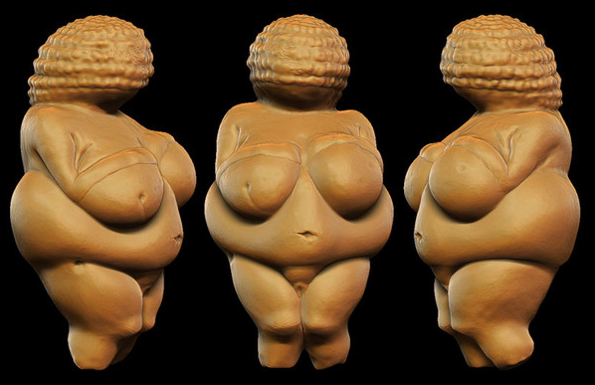

“Woman is the Creator of the Universe, the Universe is her form.
Woman is the foundation of the world....
There is no prayer equal to a woman,
There is not, nor has been, nor will be any yoga to compare with a woman,
no mystical formula nor asceticism to match a woman”
(Shakti-Sangama Tantra II.52)

Middle East | East Asia | Europe and Central Asia | Mesoamerica and Andean America | Southeast Asia and Oceana | South Asia | Africa
Sumeria Ishtar,  Cosmic uterus  Anatolia  Cybele, great mother | China  Nuwa, goddess | Norse  Ginnungagap, the void from which earth came  Greco-Roman-Phoenecian | Aztecs  Coatlicue, mother of gods | Polynesian Papa, mother earth | India Vac, goddess  Tibet  Mata-Devi, supreme goddess | Egypt  Tefnut, holy one
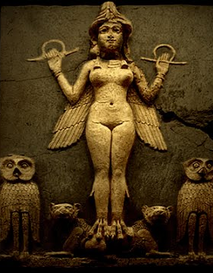  The Epic of Gilgamesh contains an episode involving Ishtar, in which she is portrayed as a femme fatale, who is simultaneously petulant, bad-tempered, and spoiled. She asks the hero Gilgamesh to marry her, but he refuses, citing the fate that has befallen all her many lovers, death.  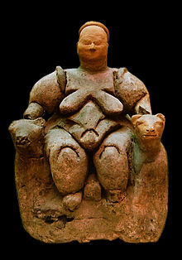 | It is said that in the beginning, surrounded by chaos was a sleeping giant named Pángǔ. The hairy, horned giant woke up and, upon standing, split the heavens and the earth. After thousands of years, he died and his body became the sun, moon, stars, mountains, rivers and forests and all else in creation. From this primordial creation, the goddess Nǚwā arrived and found that the four pillars holding heaven and earth apart were broken, so she repaired them. She then fashioned mankind from clay. | “That was the age when nothing was;  There was no sand, nor sea, nor cool waves,  No earth nor sky nor grass there,  Only Ginnungagap.”  Venus, the Roman adaptation of the Greek Aphrodite, the Phoenecian adaptation of Astarte (pictured) became one of the most widely referenced deities of Greco-Roman mythology as the embodiment of love and sexuality and the mother of humanity.  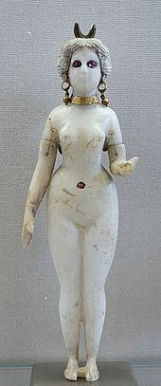 | Almost all representation of this goddess depict her deadly side, because Earth, as well as loving mother, is the insatiable monster that consumes everything that lives. She represents the devouring mother, in whom both the womb and the grave exist. 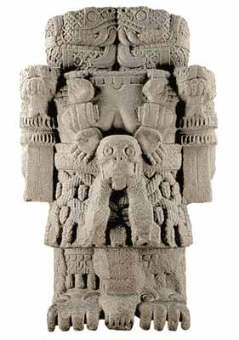  The definition of “god-fearing.” This statue depicts the absolute power of woman. | Papa is the earth mother, and is also known as Haumea. She was also called Ka-luahine. Papa and Wakea are the mother and father of Honua, the being that is the earth.  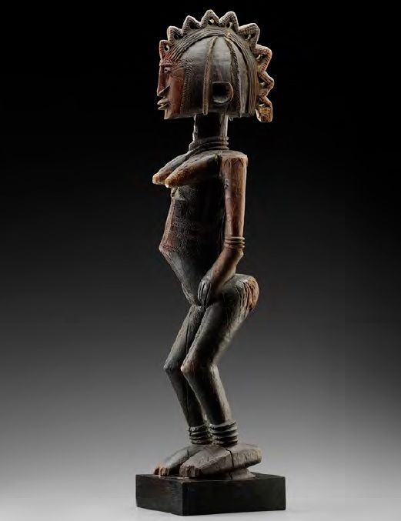  Note the exaggerated body parts, celebrating them without hiding. | “I was pregnant with all power” –recorded song in an Indian Vedic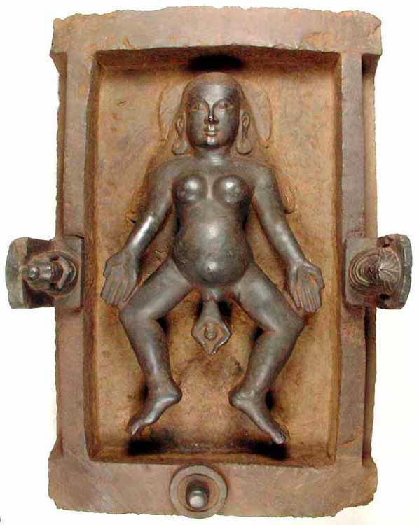  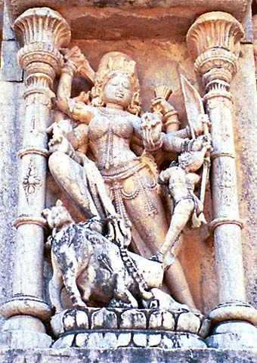  Note the unapologetic femininity and sensuality | “I am what is, what will be, and what has been. No man uncovered my nakedness, and the fruit of my birthing was the sun.” –Inscription on an Egyptian temple  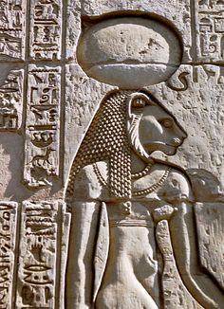  Note her beautiful and powerful lioness head.

Paleolithic Creation Stories

Of the selected goddesses and creation stories from peoples around the world, what patterns do you notice?

Are any of the stories outliers? What makes them different?

Of the surviving statues of these goddesses, what similarities and differences do you notice?

What do these stories and goddesses tell us about the role of women in Paleolithic societies?

