Susan B. Anthony’s Trial Activity
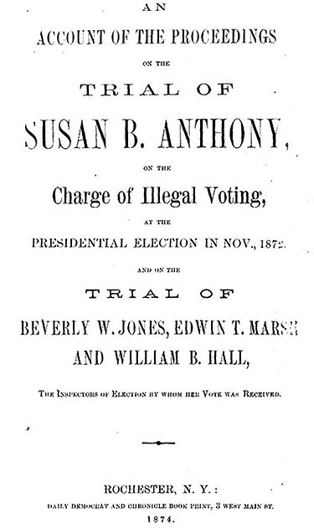
CHARACTERS:
The title page of the primary source record published account of this trial (“Wanted Susan B. Anthony”).
Miss Susan B. Anthony
Guard (swears in witnesses on the Bible)
The Judge
Mr. Crowley (prosecution attorney)
Mr. Beverly W. Jones (inspector of election)
Mr. Selden (defense attorney for Susan B. Anthony)
John E, Pound (district attorney)

"Susan B. Anthony is not on trial; the United States is on trial."--Matilda Joslyn Gage

Excerpts from the trial “US v. Susan B. Anthony”
Below is a brief review of the appellate court (lower level courts whose decisions are being challenged at the federal level) decision related to Susan B. Anthony’s arrest. This was read at her final trial.

Historian, Doug Linder, described the scene. He said, “On June 17, 1873, Anthony, wearing a new bonnet faced with blue silk and draped with a veil, walked up the steps of the Canandaigua courthouse on the opening day of her trial. The second-floor courtroom was filled to capacity. The spectators included a former president, Millard Fillmore, who had traveled over from Buffalo, where he practiced law. Judge Ward Hunt sat behind the bench, looking stolid in his black broadcloth and neck wound in a white neck cloth. Anthony described Hunt as ‘a small-brained, pale-faced, prim-looking man, enveloped in a faultless black suit and a snowy white tie’” (Linder).

Judge:
[Order in the court!]

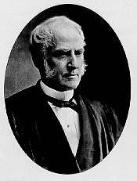
At the election of President and Vice President of the United States, and members of Congress, in November, 1872, Susan B. Anthony, and several other women, offered their votes to the inspectors of election, claiming the right to vote, as among the privileges and immunities secured to them as citizens by the Fourteenth Amendment to the Constitution of the United States.

The inspectors… decided in favor of receiving the offered votes… For this act, the women, fourteen in number, were arrested and held to bail, and indictments were found against them… The three inspectors were also arrested…All three, however were jointly indicted under the same statute—for having "knowingly and willfully received the votes of persons not entitled to vote."
Judge Hunt (Linder)

… The court held that the defendant had no right to vote—that good faith constituted no defense—that there was nothing in the case for the jury to decide, and directed them to find a verdict of guilty…The verdict of guilty was entered by the clerk, as directed by the court, without any express assent or dissent on the part of the jury. A fine of $100, and costs, was imposed upon the defendant…

Miss Anthony insists that… she has been denied her constitutional right.

[Mr. Crowley, of the prosecution, the floor is yours.]

Question to Consider: Has Miss Anthony been denied any rights thus far?

Mr. Crowley (on behalf of the government):
… On the 5th of November, 1872… The defendant, Miss Susan B. Anthony… voted…

At that time she was a woman. I suppose there will be no question about that… Whatever Miss Anthony’s intentions may have been-whether they were good or otherwise-she did not have a right to vote… there is no question but what she is guilty of violating a law…

[We] claim that upon the 5th of November, 1872, she voted… Miss Susan B. Anthony was a woman.

Question to Consider: What is Mr. Selden trying to argue?

[Judge: Mr. Selden, it would please the court to hear your rebuttal and opening statements.]
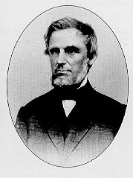
Judge Selden (Linder)
Mr. Selden (on behalf of Miss Anthony):
This is a case of no ordinary magnitude, although many might regard it as one of very little importance. The question whether my client here had done anything to justify her being consigned to a felon’s prison or not, is one that interests her very essentially, and that interests the people also essentially… She was as much entitled to vote as any man that voted at that election…

The public prosecutor assumes that, however honestly she may have offered her vote… [that] she was mistaken in… judgment… Her offering her vote and its being received makes a criminal offence- a proposition to me most abhorrent (hateful)…

Before … this election, Miss Anthony called upon me for advice. I advised her that she was as lawful a voter as I am, or as any other man is, and advised her to go and offer her vote. I may have been mistaken in that, and if I was mistaken, I believe she acted in good faith. I believe she acted according to her right as the law and Constitution gave it to her…

I propose to call Miss Anthony [to the stand] as to the fact of her voting-on the question of the intention or belief under which she voted.

Question to Consider: What is Mr. Selden trying to argue?

Mr. Crowley: [Objection!] She is not competent as a witness in her own behalf.

Judge: The Court holds. [Miss Anthony is not competent as a witness.]

Mr. Selden: Defendant rests.

Question to Consider: What Supreme Court case does this remind you of? Why?

[Mr. Crowley: The prosecution calls Mr. Jones to the stand to testify for the government.

Guard: Mr. Jones, place your hand on the Bible. Do you swear to tell the truth, the whole truth and nothing but the truth, so help you God?

Mr. Jones: I do.]

Mr. Crowley: do you know the defendant, Miss Susan B. Anthony?

Mr. Jones: yes, Sir.

Mr. Crowley: in what capacity were you acting upon that day, if any, in relation to [the] election?

Mr. Jones: Inspector of Election…

Mr. Crowley: upon the 5th day of November, did the defendant, Susan B. Anthony, vote in the First Election District of the 8th Ward of the City of Rochester?

Mr. Jones: yes, Sir.

Mr. Crowley: did you see her vote?

Mr. Jones: yes, Sir…

Mr. Crowley: did you receive the tickets from Miss Anthony?

Mr. Jones: yes, Sir…

Mr. Crowley: was Miss Anthony challenged upon that occasion?

Mr. Jones: yes, Sir—no; not on that day she wasn’t.

Mr. Crowley: she was not challenged on the day she voted?

Mr. Jones: no, Sir.

Question to Consider: Has Mr. Crowley’s strategy changed at all? What did he prove?

Judge: Mr. Selden, he is your witness.

(Cross-Examination by) Mr. Selden: Prior to the election, was there a registry of voters in that district made?

Mr. Jones: yes, Sir.

Mr. Selden: was you one of the officers engaged in making that registry?

Mr. Jones: yes, Sir…

Mr. Selden: was there any objection made, or any doubt raised as to her right to vote?

Mr. Jones: there was.

Mr. Selden: on what ground?

Mr. Jones: on the ground that the constitution of the state of New York did not allow women to vote.

Mr. Selden: what was the [problem with] her right to vote as a citizen?

Mr. Jones: she was not a male citizen…

Mr. Selden: did the board… decide that she was entitled to registry as a voter?

Mr. Jones: yes, Sir.

Mr. Selden: and she was registered?

Mr. Jones: yes, Sir.

Mr. Selden: at the time… was the supervisor of election present at the board?

Mr. Jones: he was.

Mr. Selden: was he consulted?

Mr. Crowley: (angrily) I submit that it is of no consequence whether he did or not.

Mr. Selden: he was the government supervisor under this set of Congress.

Mr. Crowley: the Board of Inspectors, under the state law, constitute the board of registry, and they are the only persons to pass upon that question [this man is not on the Board and not qualified to answer that question!]

Question to Consider: What is Mr. Selden trying to prove?

Judge: [overruled] you may take [the question].

Mr. Jones: yes, Sir… a United States Supervisor of Elections [was present], two of them.

Mr. Selden: did they advise the registry, or did they not?

Mr. Jones: one of them did.

Mr. Selden: and on that advice [they allowed Miss Anthony to vote?]

Mr. Jones: [the Board Supervisors advice] had a great deal of weight with the inspectors, I have no doubt.

Question to Consider: Why did Mr. Crowley object to Mr. Selden’s question?

[Judge: Mr. Crowley, your witness.}

(Re-direct examination by) Mr. Crowley: won’t you state what Miss Anthony said… when [registered]?

Mr. Jones: she stated that she did not claim any rights under the constitution of [New York] …she claimed her right under the Constitution of the United States.

Mr. Crowley: did she name any particular amendment?

Mr. Jones: yes, Sir; she cited the 14th Amendment.

Mr. Crowley: under that she claimed her right to vote?

Mr. Jones: yes, Sir. [She ignored the laws of the state.]

[Mr. Crowley: the prosecution calls Mr. Pound to the stand to testify on behalf of the government.

Guard: Mr. Pound, place your hand on the Bible. Do you swear to tell the truth, the whole truth and nothing but the truth, so help you God?

Mr. Pound: I do.]

Mr. Crowley: do you know the defendant, Susan B. Anthony?

Mr. Pound: yes, Sir.

Mr. Crowley: did you attend [the previous trial] when her case was examined?

Mr. Pound: I did

Mr. Crowley: was she called as a witness in her own behalf upon that examination?

Mr. Pound: she was…

Mr. Crowley: did you keep minutes [or notes] of evidence on that occasion?

Mr. Pound: I did.

Mr. Crowley: did she, upon that occasion, state that she consulted or talked with Judge Henry R. Selden, of Rochester, in relation to her right to vote?

Mr. Selden: I object to that upon the ground that it is incompetent, that if they refuse to allow her to be sworn here, they should be excluded from producing any evidence that she gave elsewhere, especially when they want to give the version, which the United States officer took of her evidence.

Judge: [overruled] go on.

Question to Consider: Why did Mr. Selden object to Mr. Crowley’s line of reasoning?

Mr. Crowley: (smiles) state whether she stated on that examination, under oath, that she had talked or consulted with Judge Henry R. Selden in relation to her right to vote?

Mr. Pound: she did.

Mr. Crowley: state whether she was asked, upon that examination, if the advice given her by Judge Henry R. Selden would or did make any difference in her action in voting, or in substance that?

Mr. Pound: she stated on the cross-examination, "I [w]ould have made the same endeavor to vote… had I not consulted Mr. Selden… I was not influenced by his advice in the matter at all; [I] have been resolved to vote… for a number of years."

Mr. Crowley: the United States rests.

Question to Consider: What did Mr. Crowley just prove?

(Cross-examination by) Mr. Selden: Mr. Pound, was she asked there if she had any doubt about her right to vote, and did she answer "Not a particle?"

Mr. Pound: She stated. "Had no doubt as to my right to vote," on the direct examination.

Mr. Selden: [Answer the question Mr. Pound!] Was not this question put to her "Did you have any doubt yourself of your right to vote?" and did she not answer "Not a particle?"

[Judge: Well he said so. Your concern is noted Mr. Selden. Sir, the floor is yours for closing remarks.]

Mr. Selden:
…The only alleged ground of illegality of the defendant’s vote is that she is a woman. If the same act had been done by her brother under the same circumstances, the act would have been not only innocent, but honorable and laudable; but having been done by a woman it is said to be a crime. The crime therefore consists not in the act done, but in the simple fact that the person doing it was a woman and not a man, I believe this is the first instance in which a woman has been arraigned in a criminal court, merely on account of her sex…

Women have the same interest that men have in the establishment and maintenance of good government; they are to the same extent as men bound to obey the laws; they suffer to the same extent by bad laws, and profit to the same extent by good laws; and upon principles of equal justice, as it would seem, should be allowed equally with men, to express their preference in the choice of law-makers and rulers…

In the [Constitution]… our ancestors declared that "governments derive their just powers from the consent of the governed."

…The teachings of history, in regard to the condition of women under the care of these self-constituted protectors, [shows that men have not protected women’s interests. Women have] in law no individual existence, and consequently no action [can] be brought by her to redress… grievous wrong[s]…

[Over the last few decades progress has been made on behalf of women]… but how [has it] been produced? Mainly as the result of exertions of a few heroic women, one of the foremost of whom is her who stands arraigned as a criminal before this Court today.

Much has been done, but much more remains to be done by women. If they had possessed the elective franchise, the reforms, which have cost them a quarter of a century of labor would have been accomplished in a year… Give them the ballot!

[Mr. Crowley: It is clear from testimony that Miss Anthony voted and, it is certainly clear that she is a woman. Mr. Selden’s arguments about just government and government authority are irrelevant.]

Judge: The judgment of the court is that you pay a fine of one hundred dollars and the costs of the prosecution. Miss Anthony, do you have anything to say why the sentence of the court should not be pronounced upon?

Miss Anthony: (stands) Yes, your honor. I have many things to say. My every right, constitutional, civil, political and judicial has been tramped upon. I have not only had no jury of my peers, but I have had no jury at all. [Am I not guaranteed a right to a jury of my peers?]

Judge: Sit down Miss Anthony. I cannot allow you to argue the question!

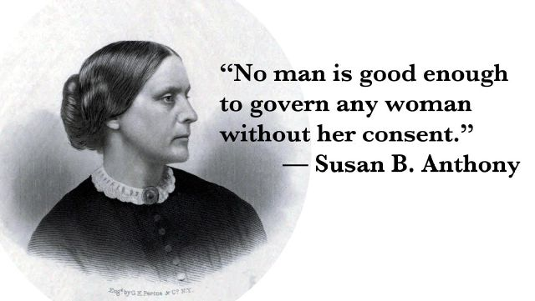
Miss Anthony: Laws [are] made by men, under a government of men, interpreted by men and for the benefit of men. The only chance women have for justice in this country is to violate the law, as I have done, and as I shall continue to do… Does your honor suppose that we obeyed the infamous fugitive slave law which forbade to give a cup of cold water to a slave fleeing from his master? I tell you we did not obey it; we fed him and clothed him, and sent him on his way to Canada. So shall we trample all unjust laws under foot. I do not ask the clemency of the court. I came into it to get justice, having failed in this, I demand the full rigors of the law.
Susan B. Anthony quotes are frequently used for women’s rights issues (“Wanted Susan B. Anthony”).

Judge: The sentence of the court is $100 fine and the costs of the prosecution.

Miss Anthony: May it please your honor, I shall never pay a dollar of your unjust penalty. All the stock in trade I possess is a $10,000 debt, incurred by publishing my paper—The Revolution—four years ago, the sole object of which was to educate all women to do precisely as I have done, rebel against your man-made, unjust, unconstitutional forms of law, that tax, fine, imprison and hang women, while they deny them the right of representation in the government; and I shall work on with might and main to pay every dollar of that honest debt, but not a penny shall go to this unjust claim. And I shall earnestly and persistently continue to urge all women to the practical recognition of the old revolutionary maxim, that "Resistance to tyranny is obedience to God."

Judge: Madam, the Court will not order you committed until the fine is paid (aka. No one is going to force you to pay it).

Bibliography:

Gardner, Page. “How Unmarried American Women Can Change the World.” Notey. 18
August 2015. http://www.notey.com/external/6554985/how-unmarried-american-women-can-change-the-world-feminism-single-women-single-mothers-pay-gap-susan-b-anthony-suffrage-movement-voting-right.html.

Gordon, Ann D., ed. Selected Papers of Elizabeth Cady Stanton and Susan B. Anthony:
Against an Aristocracy of Sex 1866 to 1873. Vol. 2. New Brunswick, NJ: Rutgers University Press. 2000. http://ecssba.rutgers.edu/docs/sbatrial.html.

Linder, Doug. “The Trial of Susan B. Anthony for Illegally Voting.” 2001. University of
Missouri at Kansas City Law School. http://law2.umkc.edu/faculty/projects/ftrials/anthony/sbaaccount.html.

“Testimony in he Case of the United States vs Susan B. Anthony.” University of
Missouri at Kansas City Law School. http://law2.umkc.edu/faculty/projects/ftrials/anthony/trialtestimony.html.

“Wanted Susan B. Anthony.” National Women’s History Museum. 5 November 2012.
http://www.nwhm.org/blog/wanted-susan-b-anthony-2/.

Susan B. Anthony Trial Activity Questions
Respond to the questions below in full sentences.

- In your own words, what legal reasons did her lawyer use to argue her case?

- For what legal reasons did the court decide against Susan B. Anthony?

- Considering the “proper pace of change,” why do you think the court decided this way?

